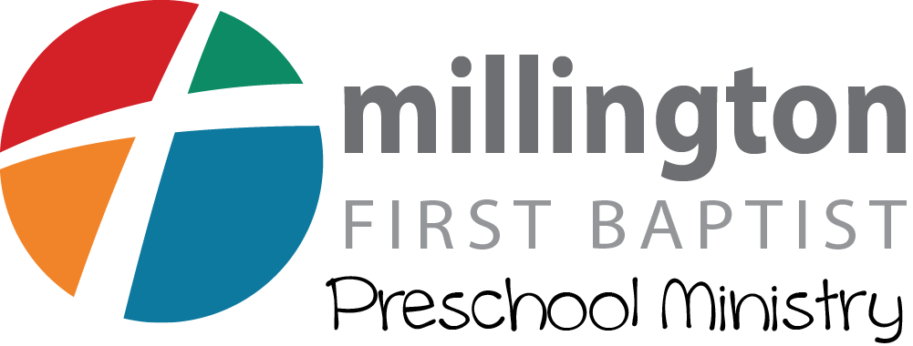

First Baptist Church
2025-2026 MDO Program
Authorization Agreement for ACH (Automatic Withdrawals – Debits)

Please complete the following ACH Authorization Form and attach a voided check to begin the process. Return the complete form to the MDO Director. Please contact us if you have any questions.

I hereby authorize First Baptist Church to debit my checking or savings (select one) account for the specific purpose of obtaining funds that are due because of fees that we have charged from First Baptist Church Mother’s Day Out Program, and if necessary, to initiate credit entries and adjustments for any debit entries in error.

Monthly drafts will occur on the 10th or the 20th day of each month or the first business day following when the 10th or 20th falls on a weekend or a banking holiday. You will receive written notice detailing the date of the first withdrawal. This authorization will remain in effect for all future charges until we receive written notice to terminate. Any payment returned by the financial institution will be subject to a $30.00 return item fee and a late fee in accordance to the policy stated in the MDO Program Handbook.

I choose the 10th of each month I choose the 20th of each month

Financial Institution: ______________________________________________________________

City: ___________________________________ State: __________ Zip Code : ______________

Routing (ABA) Number: ___ ___ ___ ___ ___ ___ ___ ___ ___

Bank Account Number: ________________________________

- Student Name: ____________________________________ Age: _____ Amount: $_________
- Student Name: ____________________________________ Age: _____ Amount: $_________
- Student Name: ____________________________________ Age: _____ Amount: $_________
Billing Name: ____________________________________________________________________
Address: _______________________________________________________________________
City: ___________________________________ State: __________ Zip Code : ______________

Home Phone: _________________ Work Phone: _______________ Cell Phone: ______________
Signature: ______________________________________________ Date: __________________

I understand that I may terminate this agreement by providing written notification to First Baptist Church. I also understand that First Baptist Church must have 10 working days to act on both authorizations and cancellation requests.

